**Short bio data**

1. Dr. Rien Dam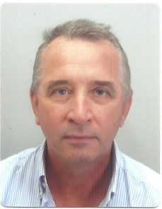
2. Biography

**Dr. Rien Dam:** **Environmental Geosciences /** **Water Resources Management.** Rien Dam (1961, The Netherlands)is an experienced international technical assistance expert with a solid basis in geosciences, IWRM, coastal zone management, quaternary geology and hydrogeology.

1. [Rien.dam@outlook.com](mailto:Rien.dam@outlook.com); WA +31 6 10475590; HP 081357850260, Jakarta
2. Current position

**Delegated Representative Water  - Indonesia (based in Jakarta)**

Coordinating collaboration between Indonesia and the Netherlands concerning WATER

[**Rien.dam@outlook.com**](mailto:Rien.dam@outlook.com) **/** [**Rien.dam@rvo.nl**](mailto:Rien.dam@rvo.nl)

1. **Dr. Rien Dam:** **Environmental Geosciences /** **Water Resources Management.** Rien Dam (1961, The Netherlands)is an experienced international technical assistance expert with a solid basis in geosciences, IWRM, coastal zone management, Quaternary Geology and hydrogeology. He has over 30 years of experience in multiple countries in Asia and Africa working as a senior project expert on urban and regional water management issues, flood risk studies, (ground)water resources management, climate change adaptation and academic geological research. He has been involved in several land subsidence studies, notably Jakarta, Central Java, HCMCity, Vietnam and regionally in SE Asia, as well as in various Quaternary Geology studies (coastal, sedimentary basins). He has worked extensively with local government organisations, knowledge sector (universities) and the private sector (consulting, technology-IT companies and start-up companies). Since 1994, he initiated and/or participated in multiple technical assistance projects in Vietnam, Laos, Bangladesh, Indonesia, Philippines and multiple African countries. Working in Indonesia since 1985 till now, he coordinated and participated in various research projects and consulting assignments and projects. He has also participated as a technical water management expert in urban planning projects in the Middle East, Vietnam and Indonesia. His project experience covers ADB, Worldbank, EU, and bilateral Dutch funded assignments.

**Some publications:**

1. **Late Quaternary Evolution of the Bandung Basin, West Java, Indonesia**, PhD Thesis (Available on request)
2. Special Issue Journal Palaeo3, Volume 171, Issues 3-4, July 2001 “**Quaternary Environmental Change in the Indonesian Region**”, Guest Editors: Rien A.C. Dam and Sander van der Kaars
3. **Sinking Cities; an integrated approach towards solutions (concerning land subsidence)**; Special report Deltares, 2013; Tom Bucx and Rien Dam.
4. **Groundwater resources in the Greater Mekong Subregion; collaborative resource management to increase resilience**; Rien A.C. Dam, Jayakumar Ramasay, Paul Pavelic, Robyn Johnston.
5. **Groundwater modeling for the Mekong Delta using iMOD**; Peter Vermeulen, Nguyen Hong Quan, Nguyen Dinh Giang Nam, Pham Van Hung, Nguyen Tien Tung, Tong Viet Thanh, Rien Dam, 2013.

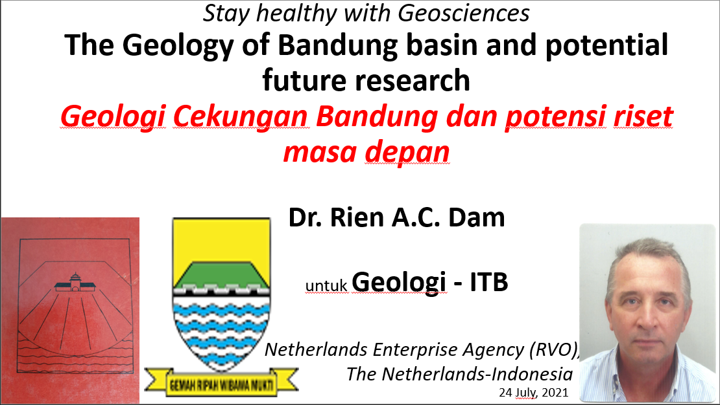

**Part 1: Introduction**

**Part 2: Bandung basin geological research**

**Part 3: Land Subsidence studies and the application of geocience studies**

**\*\*\*\*\*\*\*\*\*\*\*\*\*\*\*\*\*\*\*\*\***